

**UNIVERSITY OF PETROLEUM & ENERGY STUDIES**

**Dehradun**

**CONTINOUS INTEGRATION**

**AND**

**CONTINOUS DELIVERY**

**Name: Aakarshit Agarwal**

**Course: B. TECH CSE DevOps (2018-22)**

**Roll no.: R171218001**

**Sapid: 500067782**

**Experiment-5**

**Jenkins integration with SonarQube**

**Step-1:** Start and login to Jenkins

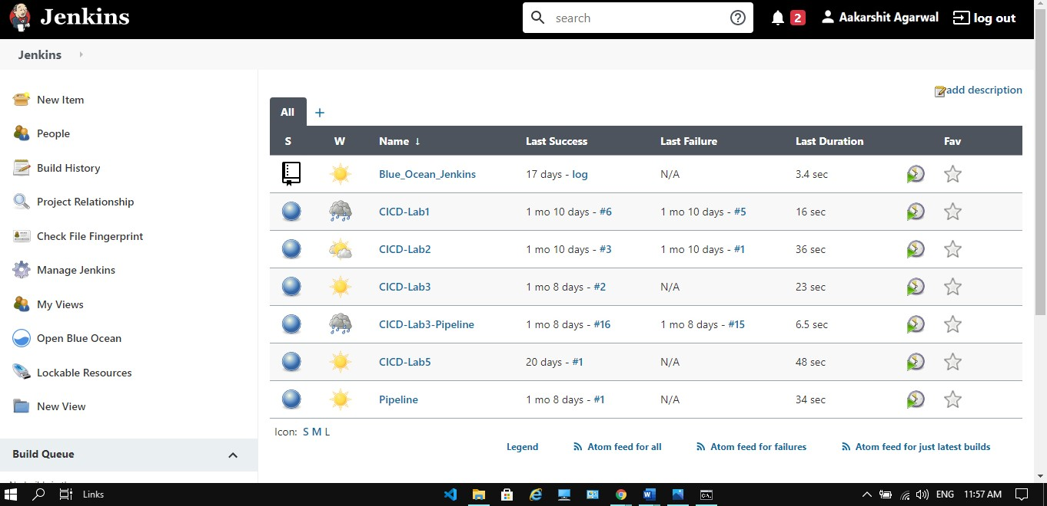

**Step-2:** Click on the new item and select maven project and provide the name to it and click on ok.

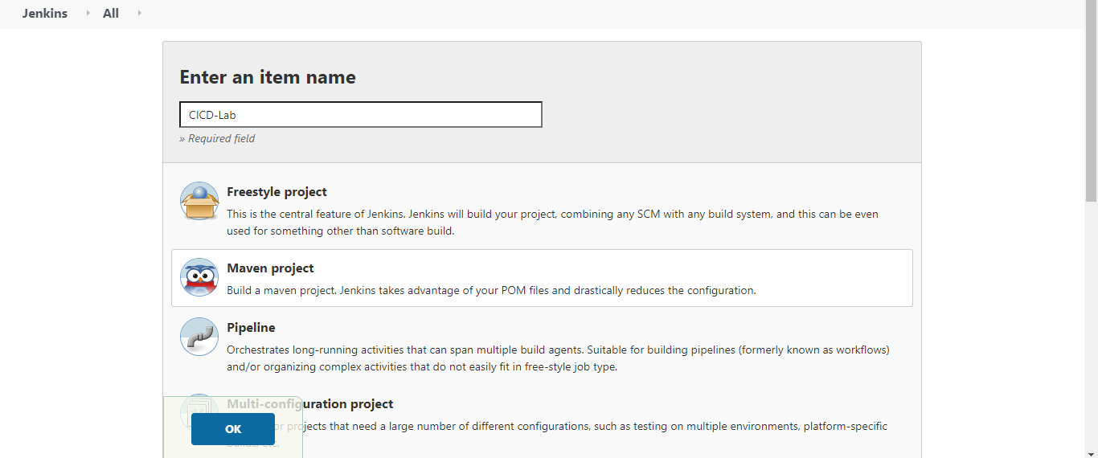

**Step-3:** provide the URL of the repository and path of pom.xml file and mention the goals. Click on Save.

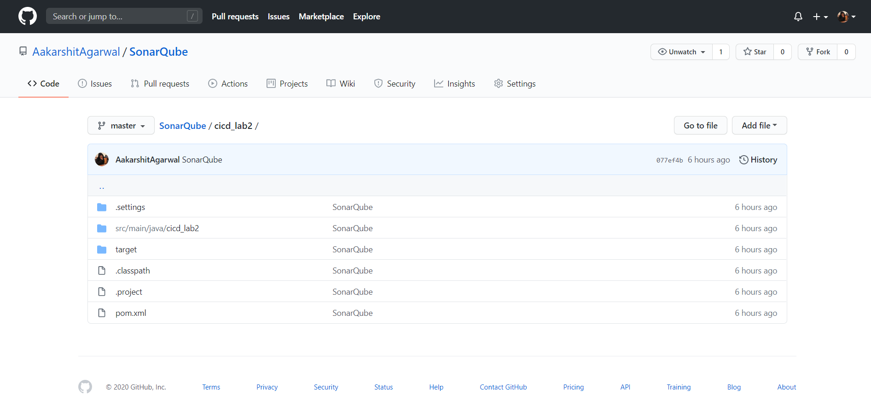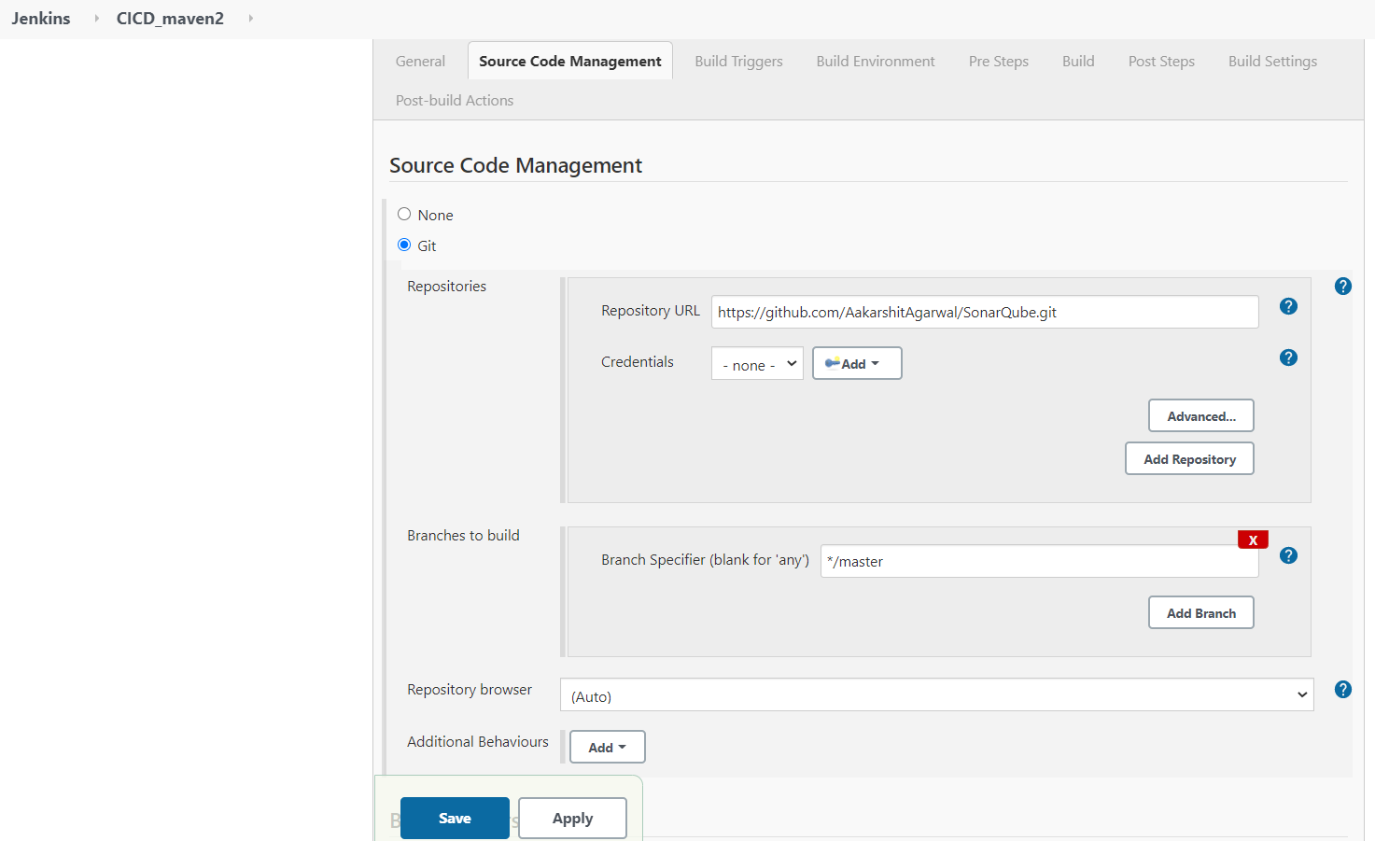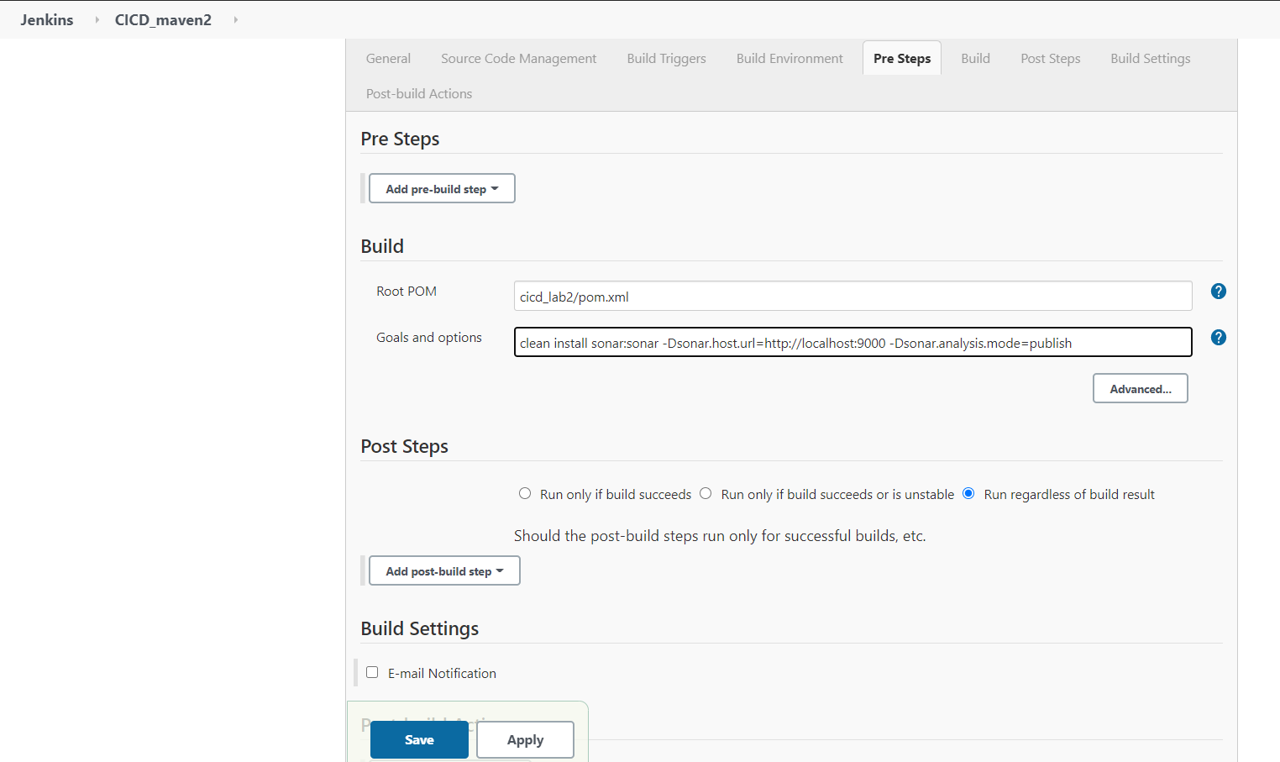

**Step-4:** Install the plugins for the SonarQube and make changes to Configuration System and provide the path.

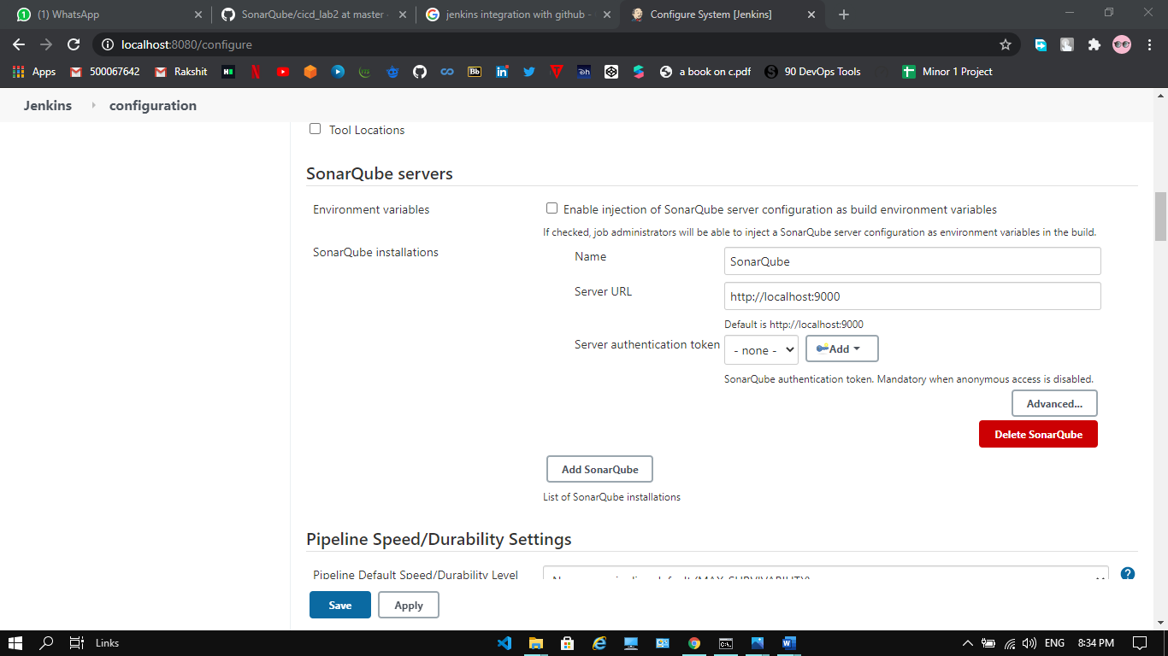

**Step-5:** Click on build now to and see the changes on SonarQube.

